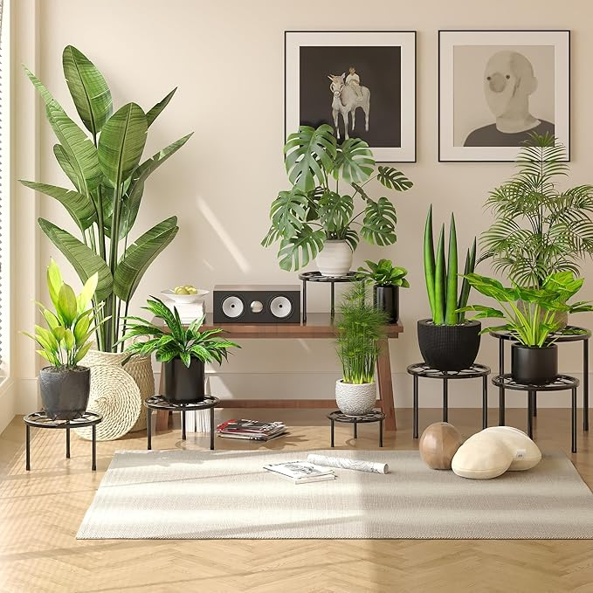

$30

VECELO Metal Plant Stands Set of 5, Multiple Heavy Duty Flower Pot Stand, Round Plant Holder, Black